Electronic Files Distribution Process

Squad Leader Instructions

Beginning with all projects Let in November 2011 and beyond, electronic copies of all design files necessary to regenerate projects plans will be delivered to Contract Standards Print Room.

Every month after the Letting list is finalized (~7 weeks prior to Let), the Records and Documents Section will email Roadway Design notifying them that the project folders for the upcoming advertisement have been created.
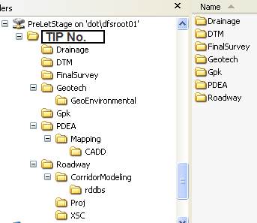
These folders will be located at:

\\dot\dfsroot01\PreLetStage\

And will have the following folder structure (for now).

All Squad Leaders have modify rights to these folders to place all necessary files.

These files need to be copied once email notification from Contracts Standards is received that your TIP folder is now available on PreLetStage. At “five weeks prior to Let deadline”, all files will be copied to another location that will allow contractors access to view these files during advertisement of the project.

All necessary files used to directly produce the set of plans need to be provided. This includes all design files, geopak files, 3D terrain files, all files produced by Corridor Modeling, and effective with the November 2014 Letting, the earthwork balance sheet.

All files will need to stay in their respective folders to retain reference integrity.

Should there be a file revision after the deadline “prior to five weeks”, the squad leader will copy the changed file into their respective subfolder AND email the Print Shop Supervisor (printshopCCB@ncdot.gov) notifying them that a revision has taken place in the file(s).

As this process evolves, it will be adapted to accommodate internal changes, industry requests, and/or to utilize capabilities that become available.

